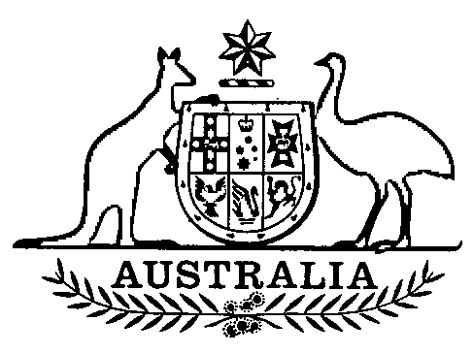
Appropriation Act (No. 3) 1992-93
No. 182 of 1992
An Act to appropriate a sum out of the Consolidated Revenue Fund, additional to the sums appropriated by the Appropriation Act (No. 1) 1992-93, for the service of the year ending on 30 June 1993, and for related purposes
[Assented to 16 December 1992]
The Parliament of Australia enacts:
Short title
1. This Act may be cited as the Appropriation Act (No. 3) 1992-93.
Commencement
2. This Act commences on the day on which it receives the Royal Assent.
Issue and application of $125 390 000
3. The Minister for Finance may issue out of the Consolidated Revenue Fund and apply for the services specified in the Schedule, in respect of the year ending on 30 June 1993, the sum of $125 390 000.
37917 Cat. No. 92 6724 1

Appropriation of $125 390 000
4. The sum authorised to be issued out of the Consolidated Revenue Fund is appropriated, and is taken to have been appropriated as from 1 July 1992, for the services specified in the Schedule in respect of the year that commenced on that day.
Money appropriated for a program
5. Where money is appropriated by this Act for a particular program, that money is taken to be appropriated for:
- the purpose of payments (including advances) under Acts administered as part of the program; and
- other purposes of the program, being purposes for which appropriation has been made in an earlier Act (other than the Appropriation Act (No. 2) 1992-93).
Act subject to Loan Act
6. This Act has effect subject to the Loan Act 1992.
SCHEDULE Sections 3 and 4
ABSTRACT
Page Reference | Departments | Total
 |  | $
4 | Department of the Arts, Sport, the Environment and Territories | 18 750 000
4 | Department of Employment, Education and Training | 76 640 000
4 | Department of Transport and Communications | 30 000 000
 | Total | 125 390 000

DEPARTMENTS

 |  | Information with respect to previous appropriation and expenditure
 | Additional appropriation for 1992-93 | Appropriation made by Appropriation Act (No. 1) 1992-93 | Expenditure for 1991-92
 | $ | $ | $
DEPARTMENT OF THE ARTS, SPORT, THE ENVIRONMENT AND TERRITORIES
Division 135.— ADMINISTRATIVE
4.— Sport and Recreation Program | 18 750 000 | 14 257 000 | 5 078 087
Total: Department of the Arts, Sport, the Environment and Territories | 18 750 000
DEPARTMENT OF EMPLOYMENT, EDUCATION AND TRAINING
Division 270.— ADMINISTRATIVE
5.— Skills Formation
02. Entry level training | 17 540 000 | 320 324 000 | 163 076 001
8.— Labour Market Program Assistance to Jobseekers and Industry | 59 100 000 | 1 080 716 000 | 585 394 470
Total: Department of Employment, Education and Training | 76 640 000
DEPARTMENT OF TRANSPORT AND COMMUNICATIONS
Division 650.— ADMINISTRATIVE
3.— Other Services
09. Road safety improvement package (including for payment to the Australian Land Transport Development Trust Fund) | 30 000 000 | 133 400 000 | 63 300 000
Total: Department of Transport and Communications | 30 000 000

[Minister’s second reading speech made in—
House of Representatives on 24 November 1992
Senate on 30 November 1992]

Printed by Authority by the Commonwealth Government Printer (278/92)



